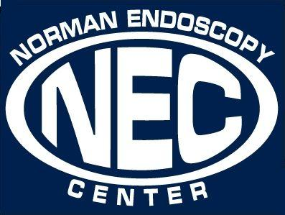
CLEAR LIQUID DIET

What is a clear liquid diet?
- A clear liquid diet is made up of clear liquids and foods that are liquid at room temperature.
- A clear liquid diet does not provide all the nutrients, vitamins, minerals, or calories that your body needs. This diet may be used before a test or surgery to make sure your digestive tract is empty. You may also need this diet after stomach or bowel (small and large intestines) surgery, or if you have problems with eating solid food.
- The goal of this diet is to provide liquids and part of the calories you need until you can eat solid food. Clear liquids are easily digested and do not put a strain on your stomach or intestines.
What can I eat and drink on a clear liquid diet:
- Clear juices (such as apple, cranberry or grape), strained citrus juices
- Strained lemonade, limeade or fruit punch
- Kool-Aid®
- Italian Ice
- Honey
- Weak tea or coffee, without creamer or milk
- Mineral, bubbly, or plain water
- Clear soft drinks like ginger-ale, lemon-lime soda, or club soda (No cola or root beer)
- Clear sports drinks or Gatorade®
- Clear broth, bouillon, or consomme’
- Plain popsicles. Avoid popsicles with pureed fruit or fiber in them
- Hard candy
- Flavored gelatin, such as Jell-O® without fruit. You may also drink gelatin as a warm beverage before it sets
- Slushies or Icees® (once the ice melts in these, they will become liquid)
What should I avoid eating and drinking while on a clear liquid diet?
- Any beverage that you cannot see through
- Beverages containing alcohol
- Dairy products such as milk, hot cocoa, buttermilk and cream
- Fruit smoothies, nectars, fruit juices with pulp and prune juice
- Tomato juice
Risks:
- If you do not follow this diet before your test or surgery, your test of surgery may need to be scheduled for another time.
- If instructed to follow a clear liquid diet because your body cannot digest solid food, not following the diet as ordered may lead to diarrhea, nausea and vomiting, gas or bloating.
- The clear liquid diet does not provide all the nutrients you need. If directed to follow a clear liquid diet over two or three days, you should drink a clear liquid nutritional supplement, such as Ensure Clear®.

